SID: 79489799

Base URL: https://www.sciengine.com/JFCT/home

Go to this site and capture Vol and Issue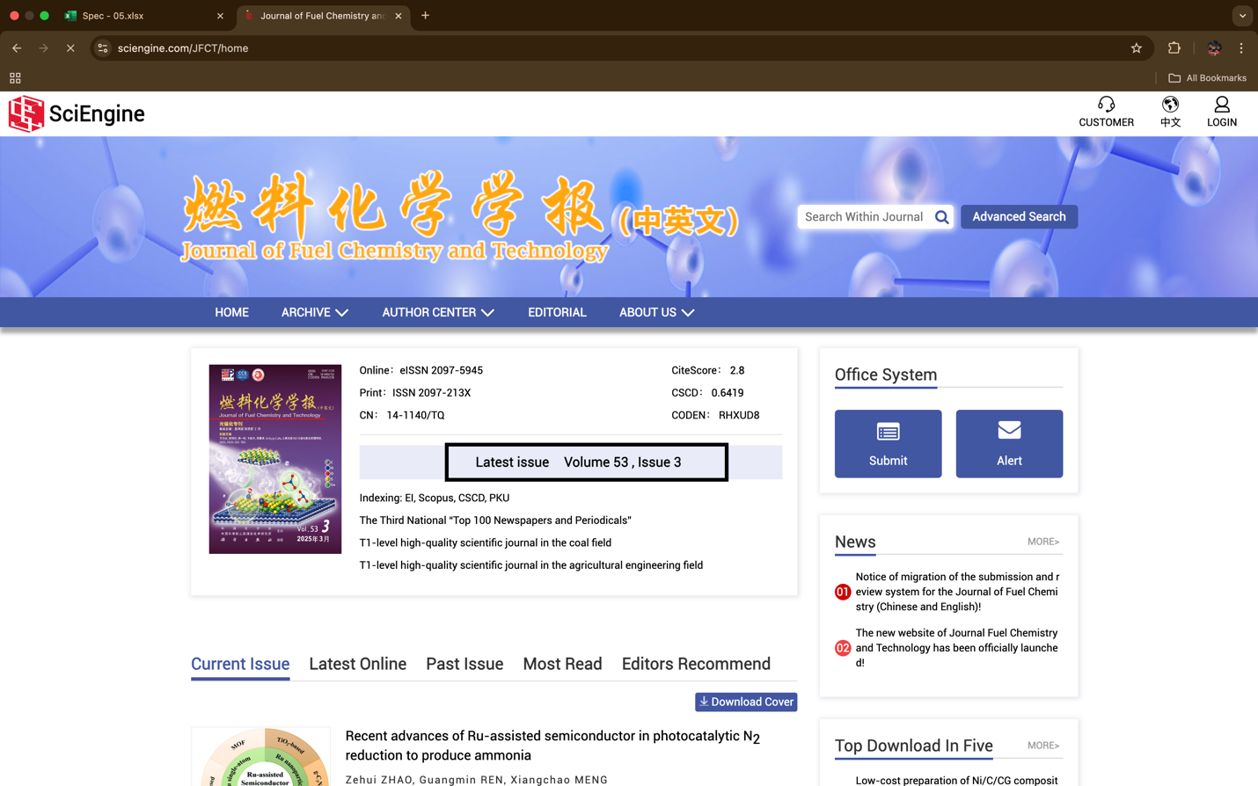

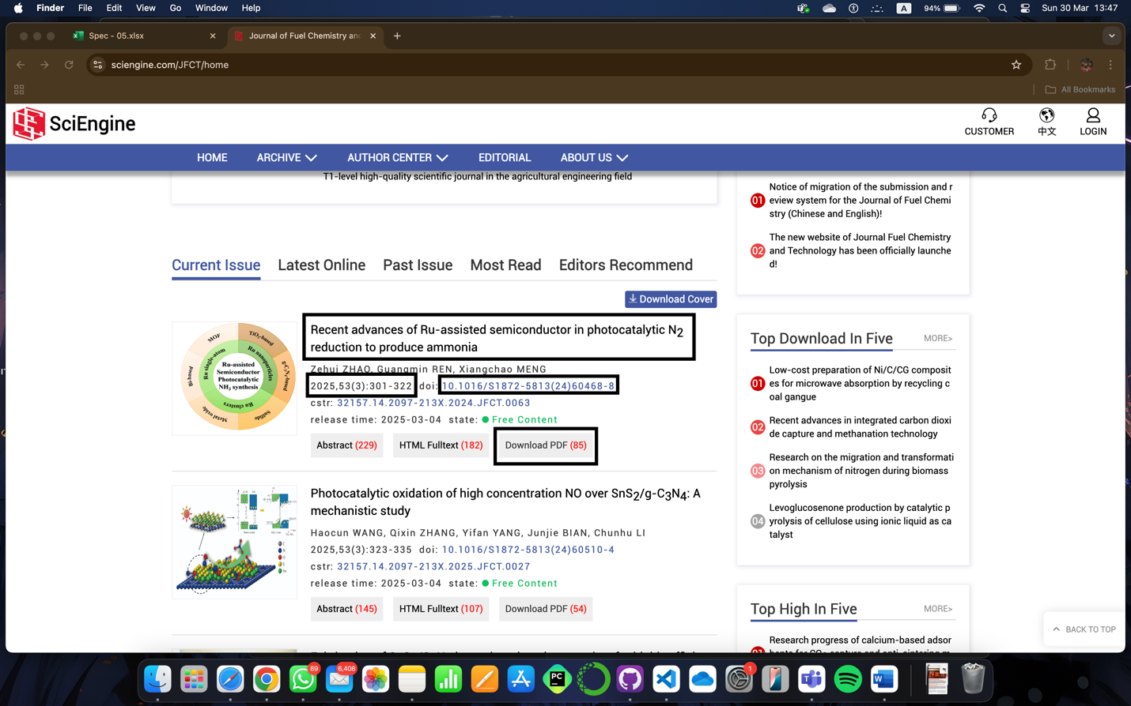

Download PDF

Capture DOI

Capture Vol & Issue Page range

Capture title

Repeat this process till the last article in this issue.